Sir Syed University of Engineering & Technology
University Road, Karachi 75300
http://www.ssuet.edu.pk

DIGITAL SIGNAL PROCESSING LAB (CE-320L)
PROJECT REPORT
NUMBER PLATE RECOGNITION

GROUP MEMBERS:
NAME | ROLL NUMBER
ABDULLAH ALAM | 2023F-BCE-028
ARHAM SIDDIQUE | 2023F-BCE-023
RAYYAN GODIL | 2023F-BCE-216
SHIEKH MUHAMMAD SAMI | 2023F-BCE-207

SUBMITTED TO: Engr SIDRAH FATIMA

TABLE OF CONTENT:
1) | INTRODUCTION
2) | OBJECTIVE
3) | THEORY/BACKGROUND
4) | SOFTWARE AND HARDWARE REQUIRMENTS
5) | SYSTEM DESIGN AND METHODOLOGY  - DATABASE SETUP  - GUI DESIGN  - RECOGNITION ALGORITHM\  - TAX AND SECURITY ALERT LOGIC
6) | CODE
7) | OUTPUT
8) | RESULT AND OBSERVATION
9) | CHALLENGES FACED
10) | CONCLUSION
11) | REFERENCE

- INTRODUCTION:
The Number Plate Recognition System is a digital image processing project designed to identify and verify vehicle registration plates. This system can be used for traffic monitoring, security surveillance, and law enforcement to detect vehicles that are registered, stolen, or have pending taxes.
This project implements a premium car recognition system using MATLAB, integrating both optical scanning and a secure vehicle dataset. The system features an interactive GUI that displays decrypted vehicle information, alert messages for stolen vehicles, and tax status visualization.

- OBJECTIVE:
To design a system capable of recognizing and verifying vehicle registration numbers.
  - To maintain a secure dataset of vehicle details including owner, make, model, and tax status.
  - To provide real-time alerts for stolen vehicles or expired tax status.
  - To develop an interactive and visually appealing GUI using MATLAB’s uifigure functionality.

- THEORY / BACKGROUND:
Number Plate Recognition (NPR) combines Digital Image Processing (DIP) and database matching. Key concepts:
Optical Recognition: Capturing text from images and matching against a pre-existing dataset.
- Data Matching: Comparing scanned input with stored license plates to retrieve vehicle details.
- GUI Representation: Displaying decrypted data in a readable format with color-coded alerts.
The project uses MATLAB as the primary platform due to its strong support for image processing, GUI design (uifigure, uibutton, uiaxes), and structured data handling (struct arrays).

- SOFTWARE AND HARDWARE REQUIRMENTS:
Software:
- MATLAB R2022b or higher
- Image Processing Toolbox (for displaying vehicle images)
Hardware:
- Standard PC or Laptop
- Screen to display GUI
- Sample vehicle plate images (named as plate1.jpg, plate2.jpg, …)

- SYSTEM DESIGN AND METHODOLOGY
- DATABASE SETUP
The system uses a structured database stored in MATLAB as a struct array with fields:
- Owner
- Colour
- Engine Number
- Chassis Number
- Tax Status
- Tax Year
- Make & Model
- Manufacturer
- Capacity
- Body Type
- Horsepower
- Vehicle Class
- CPLC (stolen/clear status)
Example database snippet:
plates = {'BDM-870', 'BCR-276', ...};
data = struct( ...
'Owner', {'Mustafa Khan', ...},
'Color', {'Gun Metallic', ...},
'EngineNo', {'E-55421', ...}, ... );
The system supports 10 slots, with some slots acting as placeholders for testing unregistered plates.
- GUI DESIGN
The GUI is divided into two main panels:
- Left Panel (Optical Feed):
  - Text input field for entering the plate number
  - Scan button with interactive animation
  - Axes to display vehicle images
- Right Panel (Secure Dataset):
  - Displays vehicle details retrieved from the database
  - Labels color-coded to highlight tax status and stolen alerts
Design Theme: Cyber-tech dark mode with cyan accents and grey text for readability.
- RECOGNITION ALGORITHM
• Input: Plate number entered in text field (uieditfield).
• Matching: Compare input with plates database using strcmp.
• Validation:
- If plate not found → ACCESS DENIED alert.
- If plate found → retrieve all vehicle data and populate GUI labels.
• Alerts:
- Stolen vehicle → red font, FIR alert popup.
- Tax paid → green font, unpaid or expired → red font.
• Image Display:
- Load vehicle image named according to index (plate1.jpg, plate2.jpg, etc.).
- Show “NO SOURCE IMAGE” if image file is missing.
- TAX AND SECURITY ALERT LOGIC
• Stolen Vehicles: Detected via CPLC field.
• Tax Status Visualization:
if strcmpi(res.TaxStatus, 'Paid')
displays{5}.FontColor = [0 1 0]; % Green
else
displays{5}.FontColor = [1 0.2 0.2]; % Red
end
• Dynamic Feedback: GUI button changes to “SCANNING...” and then “SCAN COMPLETE”.
- CODE:

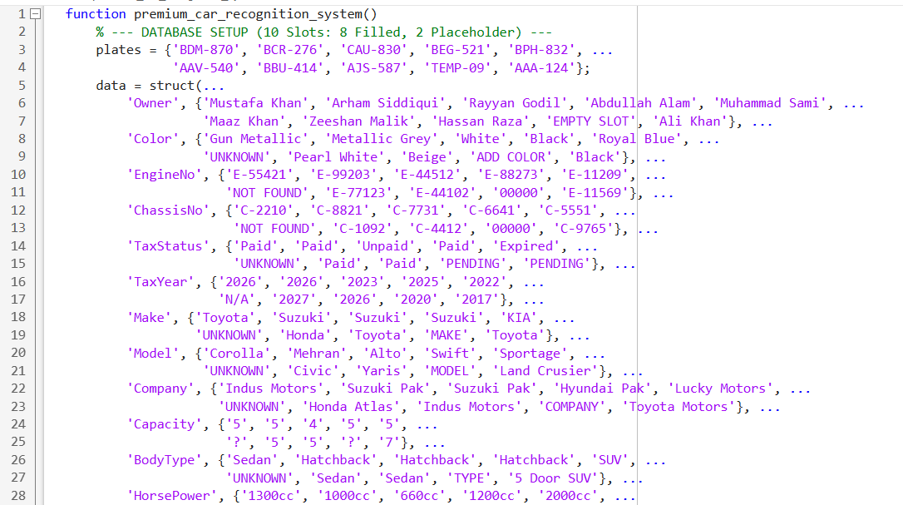
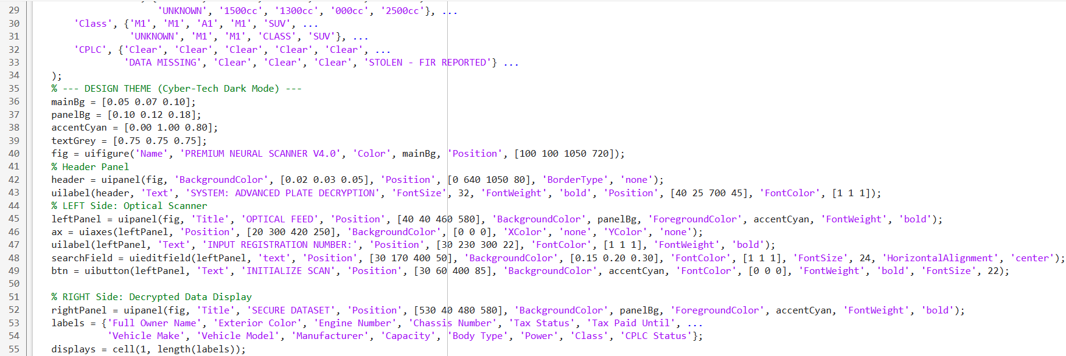
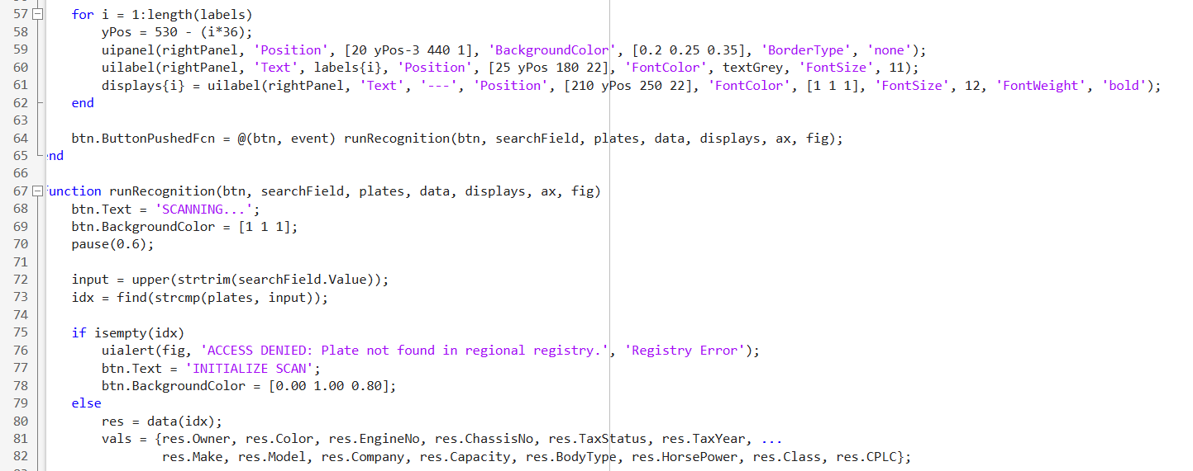
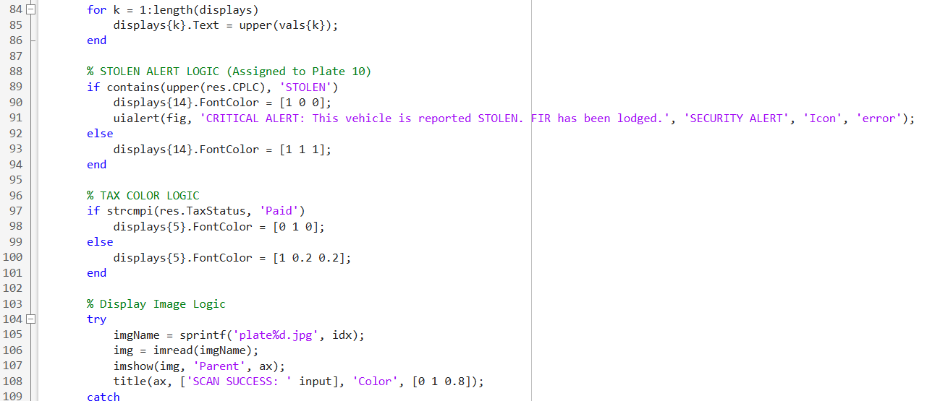
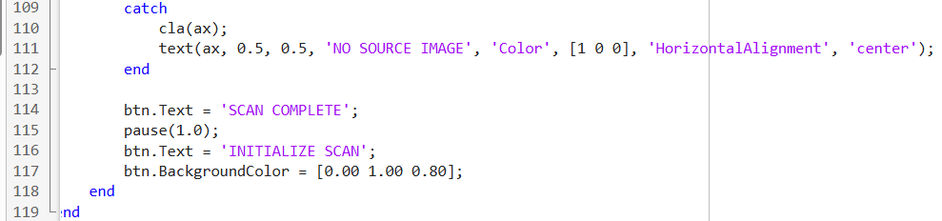

- OUTPUT:

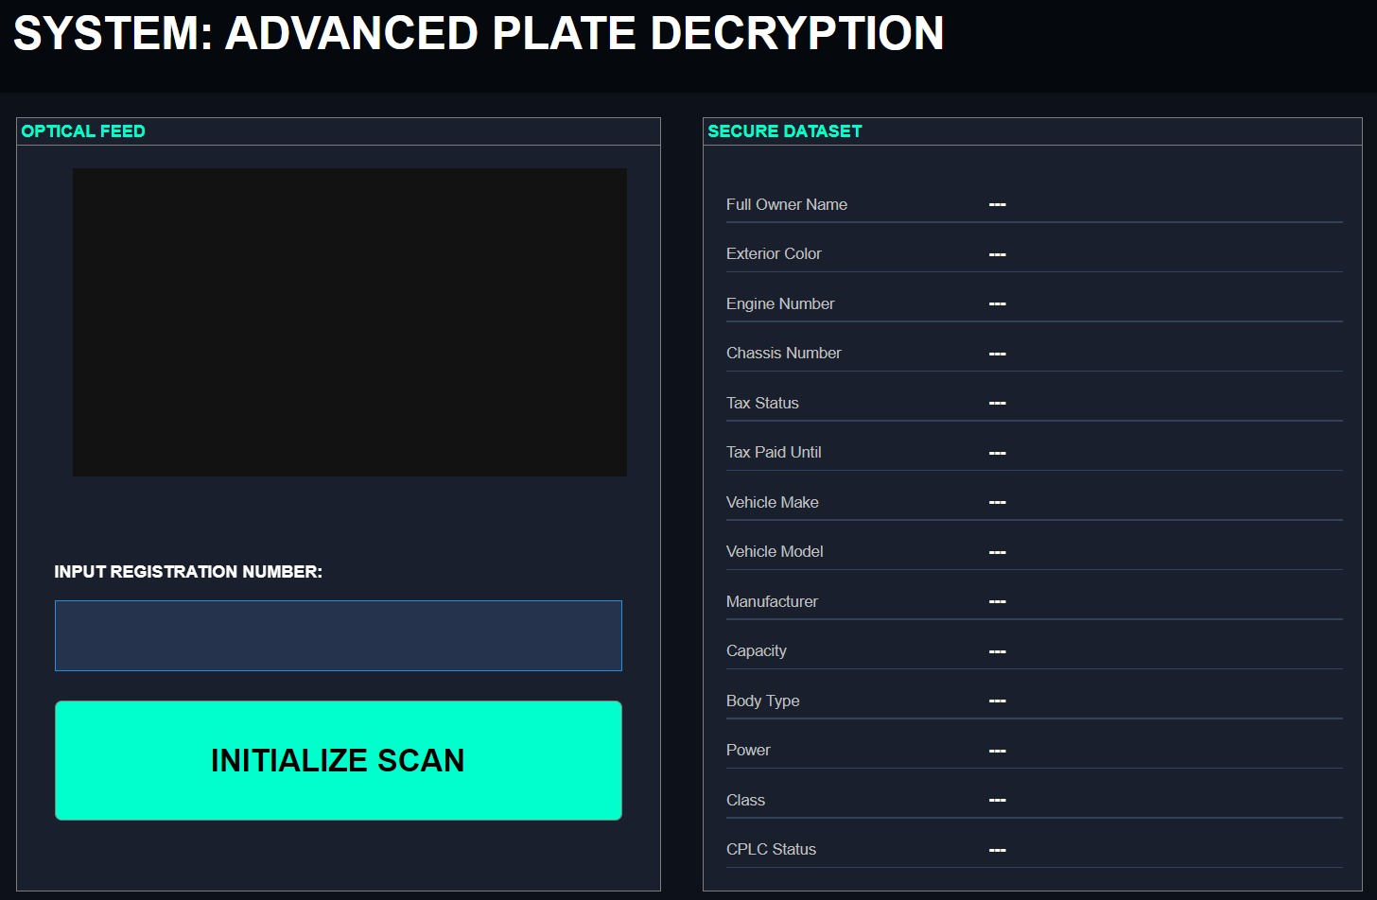
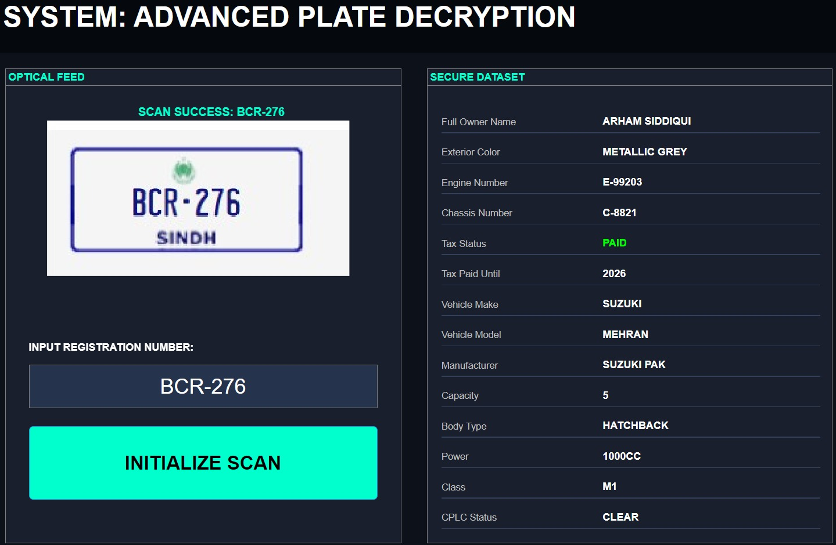

- FOR STOLEN CAR:
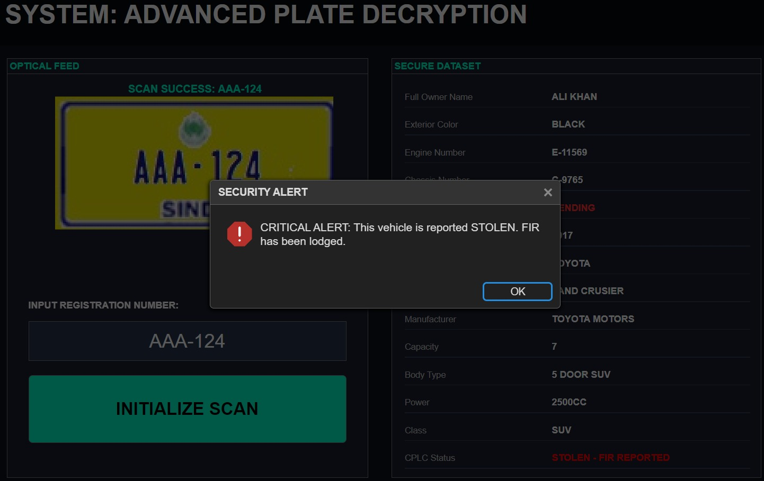

- FOR CAR NOT IN OUT REGISTRY:
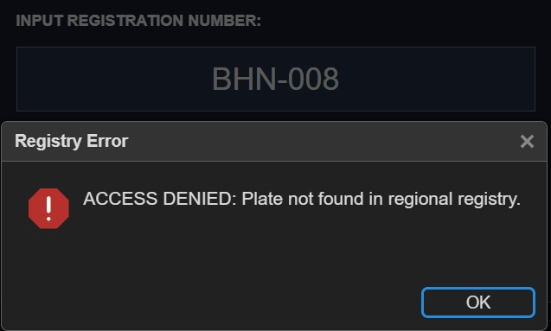

- RESULT AND OBSERVATION:
• Successfully recognized registered vehicle plates and displayed all details in GUI.
• Correctly alerted stolen vehicles and displayed FIR warning.
• Color-coded tax status clearly distinguishes between paid and unpaid vehicles.
• Missing images display “NO SOURCE IMAGE” without crashing the program.

- CHALLENGES FACED:
- Ensuring GUI dynamically updates labels and colors correctly.
- Handling missing or incorrect image files without breaking program flow.
- Designing the dataset in a way that supports placeholder and test entries.

- CONCLUSION:
The project successfully demonstrates a Digital Signal Processing (DSP) application for vehicle plate recognition. It integrates optical scanning, structured database verification, and GUI-based user interaction. The system can be extended with real-time camera feed for live plate recognition and larger vehicle datasets.
This system highlights the importance of integrating image processing, data structuring, and interactive visualization in modern DSP projects.

- REFERENCE:
• Rafael C. Gonzalez, Richard E. Woods, Digital Image Processing, 4th Edition.
• MATLAB Documentation: https://www.mathworks.com/help/matlab/
• Tutorials on MATLAB GUI Design and Image Processing

